**Presenter Proposal Form**

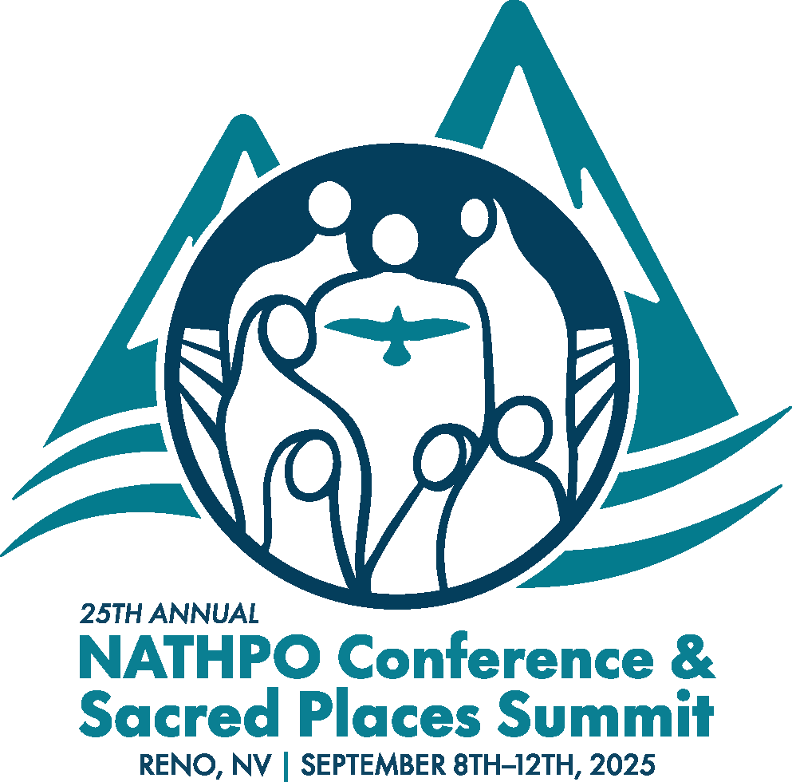

***Upholding Tribal Sovereignty: Protecting Native Places in a Shifting Landscape***

Please return at your earliest convenience and no later than **June 06, 2025**.

NATHPO invites you to share your knowledge and experiences in Tribal historic and cultural preservation. Presenting your work in this forum is a great way to reach others who work in similar topics, get feedback and encouragement, and build partnerships to support and continue your work.

This year’s theme is “Upholding Tribal Sovereignty: Protecting Native Places in a Shifting Landscape.” This is a historic moment of opportunity for elevating Native voices at the highest level. We must come together during this time to speak up for Tribal historic preservation and sacred places.

We appreciate your interest in presenting information at the 25th Annual NATHPO Conference. Please understand that we cannot guarantee that you or your organization will be chosen as a presenter. Presentation selections are made based upon available time, conference theme, and material content. The Board of Directors may help NATHPO staff in selecting proposals.

As always, we welcome sessions and presentations from all sectors, and on all relevant topics. We encourage you to think about how your proposed topic is related to the conference theme. Presentations by Tribal representatives will be prioritized. If your proposal is accepted, we will ask you to provide presentation materials in advance of the conference.

###### Coordinator and/or Primary Contact:

|  |  |
| --- | --- |
| Tribe/Organization: | |
| Contact Name & Title: | |
| Address: | |
| Telephone: | Email: |

**Title and Description of Your Session**

The title and description should accurately reflect the content, activities, and anticipated outcomes of your session. Please be specific. We reserve the right to edit titles and descriptions for use in the conference materials. Attach additional pages if necessary.

|  |  |
| --- | --- |
| Proposed Title: |  |

|  |  |  |
| --- | --- | --- |
| Presenters: |  | |
| Description: | |  | |
|  | | | |
|  | | | |
|  | | | |
|  | | | |
|  | | | |
|  | | | |
|  | | | |
|  | | | |
|  | | | |
|  | | | |
|  | | | |
|  | | | |
|  | | | |
|  | | | |
|  | | | |
|  | | | |
|  | | | |
|  | | | |
|  | | | |
|  | | | |
|  | | | |
|  | | | |
|  | | | |
|  | | | |
|  | | | |

##### **Please return completed form via email to:**

Valerie Grussing, NATHPO Executive Director

[valerie@nathpo.org](mailto:valerie@nathpo.org), (202) 628-8476

and copy to: [info@nathpo.org](mailto:info@nathpo.org)